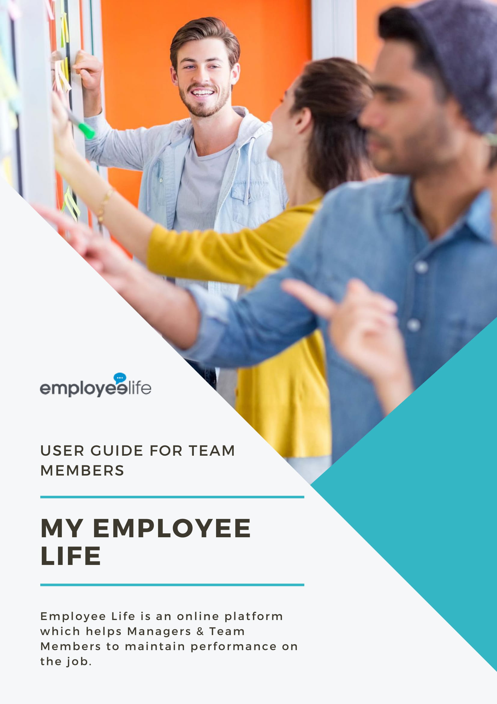

1 GETTING STARTED 4
1.1 Create Your Profile 4
2 Navigating My Employee Life 5
2.1 Posts 5
2.1.1 Give your post a title and add the content. 6
2.1.2 Click ‘Private to select who you want to share the post with. If you don’t share a post, it will remain private to you. 7
2.1.3 Close the window to return to the post. 7
2.1.4 Click Post to immediately share it. 8
2.1.5 To comment on a post, simply click the post you want to comment in, type your comment below the comment box. Then, “Post Comment”. 9
2.1.6 To like a post or comment click the “like” link. 9
2.2 Goals 9
2.2.1 Click on Add + at the top of the screen. You may either copy a previous goal or create a new one. The following steps are for creating a new goal. 11
2.2.4 Set the Start Date and End Date. 12
2.2.5 Under the Goal dashboard, click the “+’ to add a goal. 12
2.2.6 To add “Key Results”, click “Add +” button. 13
2.2.7 Type the title of the new key result. 13
2.2.8 Add notes (if applicable) and adjust the progress bar according. 14
2.2.9 Further key results can be added by repeating the above steps. 14
2.2.10 Click Create Goal button to save all Goal. 15
2.3 Work Logs 15
2.3.1 Click on the Work Log Menu item 16
2.3.2 Give your work log a title. 16
2.3.3 You may also attached files, or posts, worklogs, goals, and tasks. 16
2.3.4 Click the “Private” button to add people to share with. 17
2.3.5 Type the name of colleague or group to whom the work log is to be shared with, or select from the list. 17
2.3.6 Click Post button to post the work log. 17
2.4 ACTIONS 18
2.4.1 Click Actions menu from the Sidebar. 18
2.4.2 Click the Add+ button to add a task. 18
2.4.3 Type the Title of the Task on the text field and add notes if applicable. 19
2.4.4 Add the Due Date 19
2.4.5 Type the name (first or last name) of the assignee in the text field. Select the assignee from the list. 20
2.4.6 Set the status of the task. 20
2.4.7 Click Create Action button to save the new Task. 20
2.5 Files 22
2.5.1 Click the Files tab on the side bar of the dashboard. Click the “+ New Folder” to upload a folder and “+ New File” to upload a single file. 22
2.5.2 Drag and drop or browse files you want to upload. 22
2.5.1 To share a file with your team, click the “Private” button. Type in the name or select the group you want to share the file with. 23
2.6 Teams 25
2.6.1 Click Teams on the side menu. 25
2.6.2 Click the department of the team member you are looking for. And it will direct you to the list of all the team members of that department 26
2.6.3 Click the profile of the person you are looking for and you may now view the information that has been shared to you from the person. 26
3 BRINGING IT ALL TOGETHER - CREATING AND MAINTAINING A ‘PERFORMANCE DRUMBEAT’ 27
3.1 Performance Reviews 28

GETTING STARTED
This document provides details of all available features of My Employee Life, however as you will discover later, we recommend starting out with the core features first and build up from there.
Let’s get started with creating your profile.

Create Your Profile
When first logging in, you will be directed to the Profile page to complete your profile information.
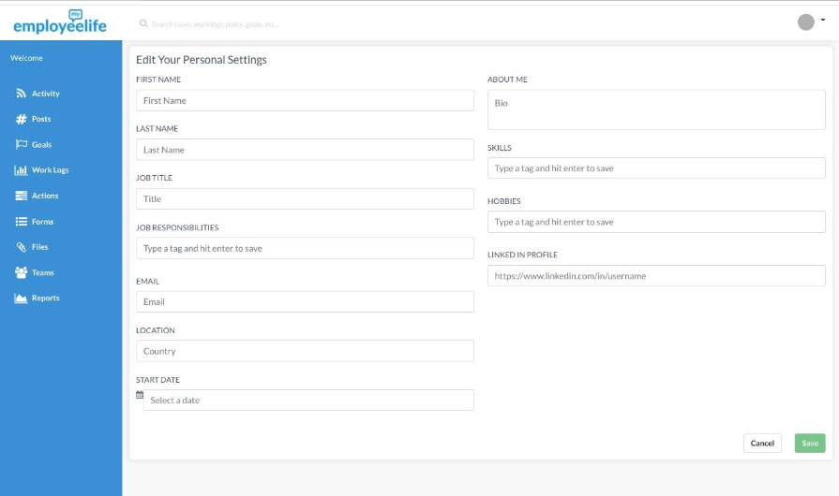

Save your profile and then click “Upload New Avatar”.
Click “Browse Files” to upload a photo and click “Upload Avatar”
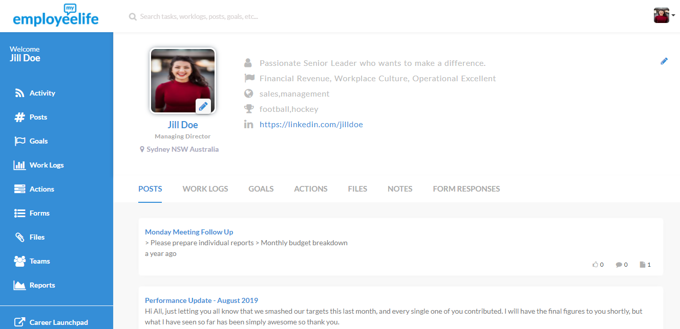

Navigating My Employee Life
The main menu is on the left.

The first page you will see is the Summary Page. It displays all activity that has been shared with you across My Employee Life, including Posts, Goals, Worklogs, Actions, Forms, Files, Teams, Reports, and the Career Launchpad.

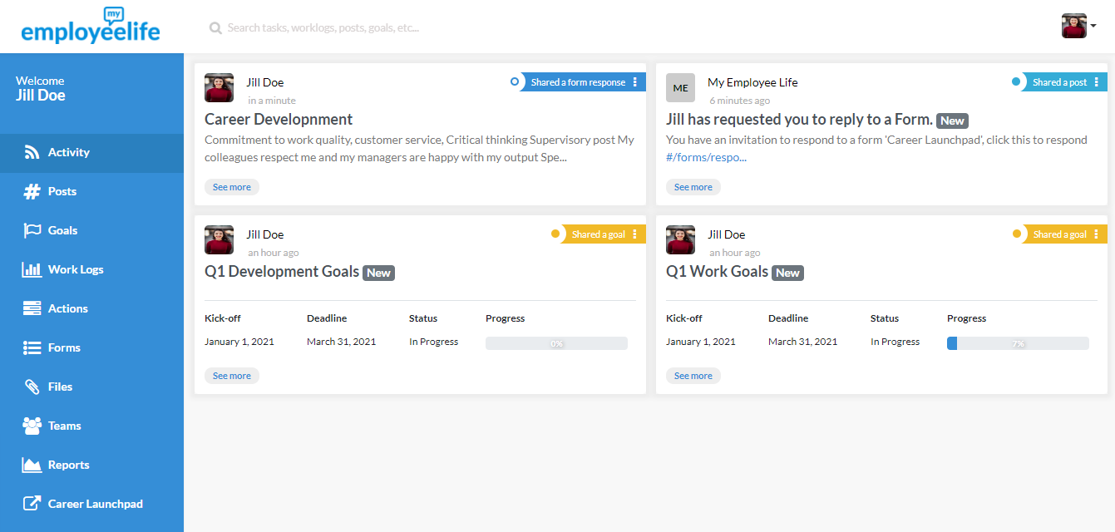

Let’s now look at each of these in more detail.

Posts
Posts are general communications that you created and have been shared with you by someone else.

To create a post, simply click Posts on the main menu, then click the “+” icon on the lower right corner.

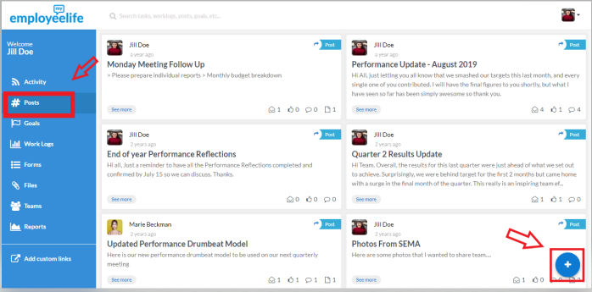

Give your post a title and add the content.
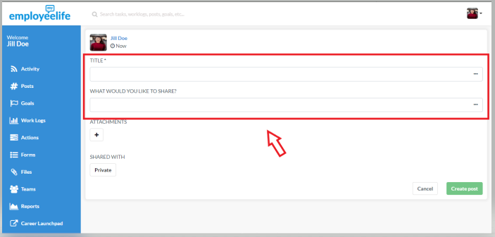

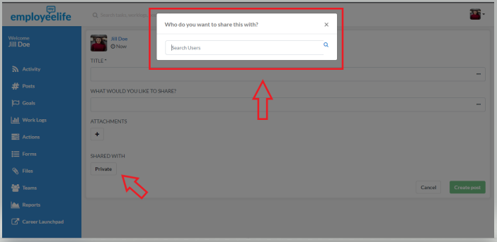
Click ‘Private to select who you want to share the post with. If you don’t share a post, it will remain private to you.

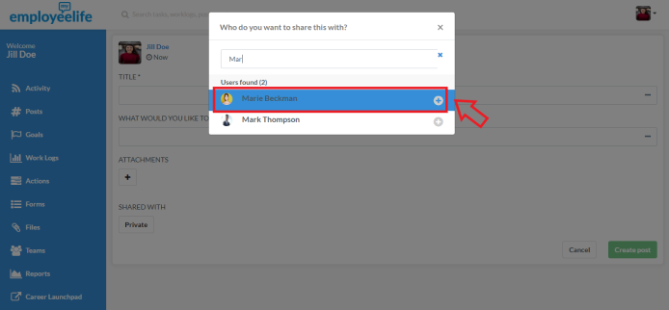

Close the window to return to the post.

Click Post to immediately share it.

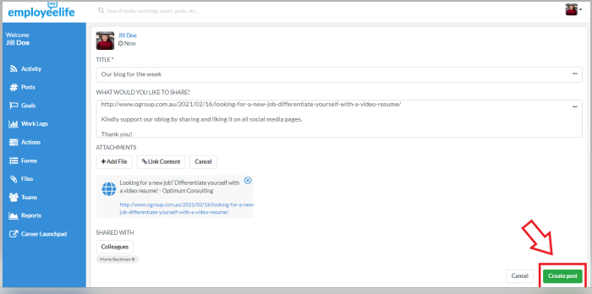

(Posted update)
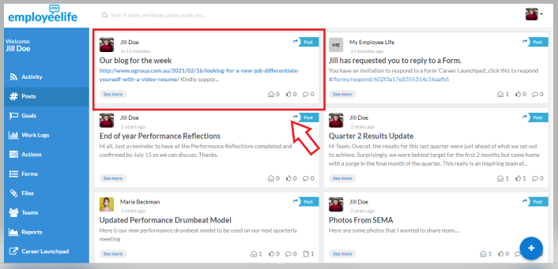

To comment on a post, simply click the post you want to comment in, type your comment below the comment box. Then, “Post Comment”.
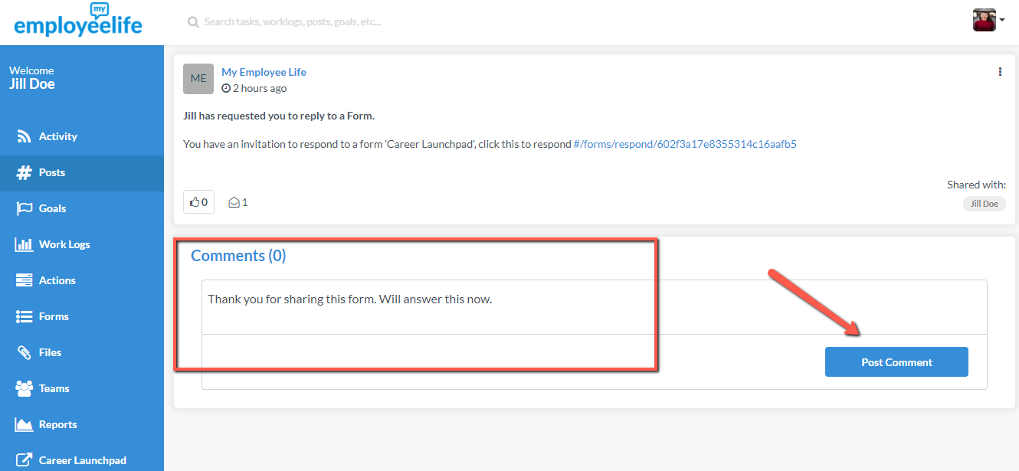

To like a post or comment click the “like” link.
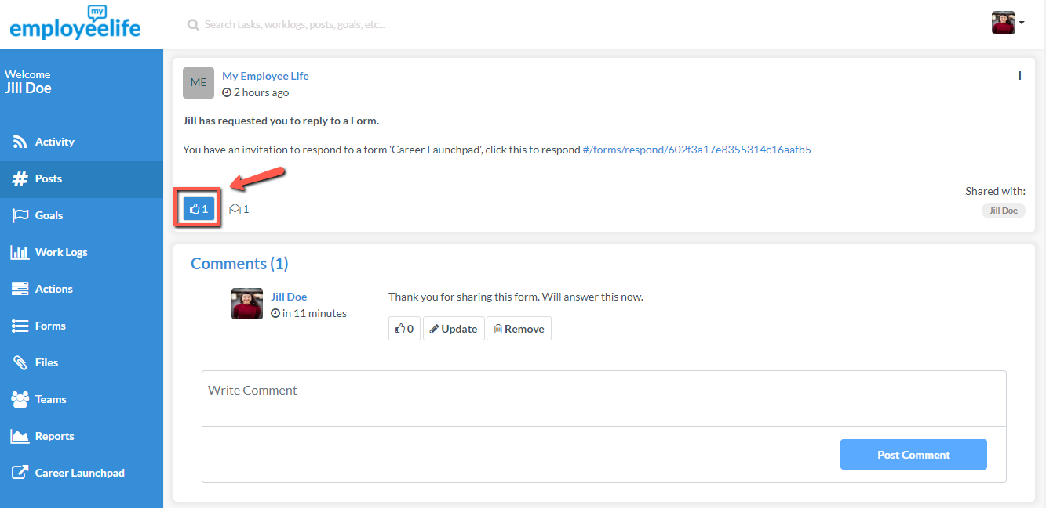

Goals
Goals describes a point in the future that you are aiming to get to. It could be in terms of work output, career development, or other medium or long-term goals. These are usually agreed with your supervisor, although you can also use My Employee Life to track your own personal goals. (If you want to keep a private goal, don’t’ share it with others).
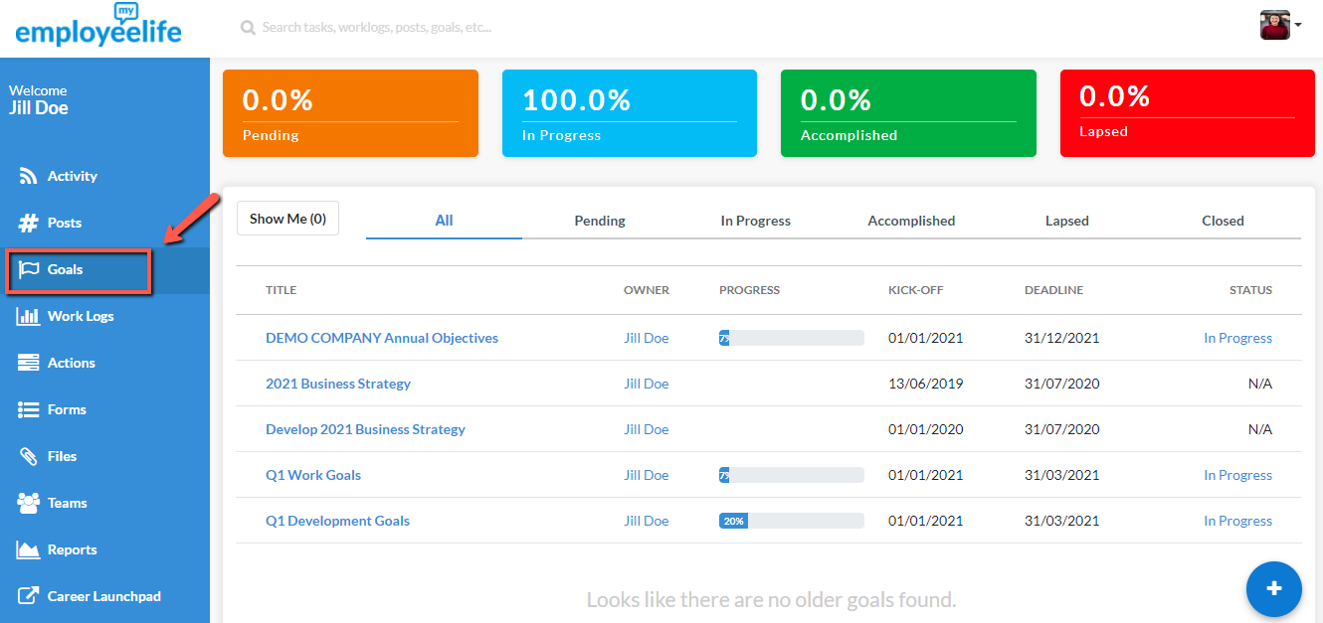

We have adopted the same terminology that Google uses for their goal setting process - OKR’s - ‘Objectives’ and ‘Key Results’.
An Objective is simply a topic/subject area (e.g. Financials, People) that usually aligns with the objectives of the Company overall. Objectives may contain one or more Key Results that are measurable and usually contain a number or metric (e.g. $120,000 sales, hire and onboard 3 new staff members).
Another way to think of Goals is ‘Focus Areas’ – in other words, they are simply things that need attention and focus.
The Goals page displays your goals and those shared to you by others in the following categories:
- Pending – haven’t yet started.
- In Progress – are currently in progress.
- Accomplished – have reached 100% completion.
- Lapsed – Completion data is passed
- Closed – Goal can no longer be edited, by is kept for referencing.
These categories form part of what we describe as the Performance Drumbeat, which we explain in the next section.
Here’s how to create a goal…

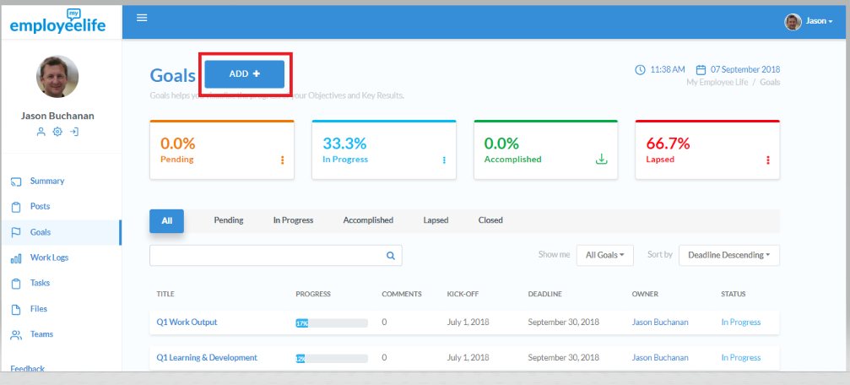
Click on Add + at the top of the screen. You may either copy a previous goal or create a new one. The following steps are for creating a new goal.

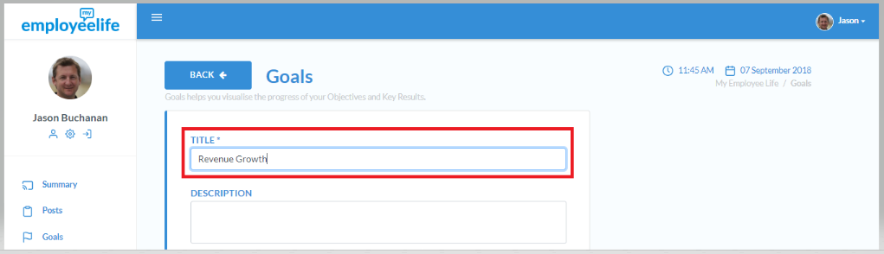
2.2.2 Type the title of the Goal.

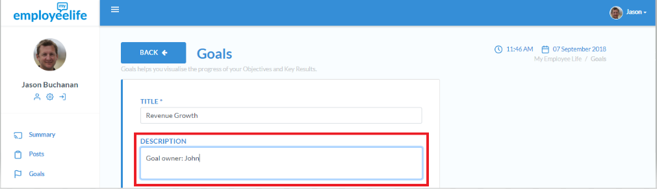
2.2.3 Add description/notes (if applicable)

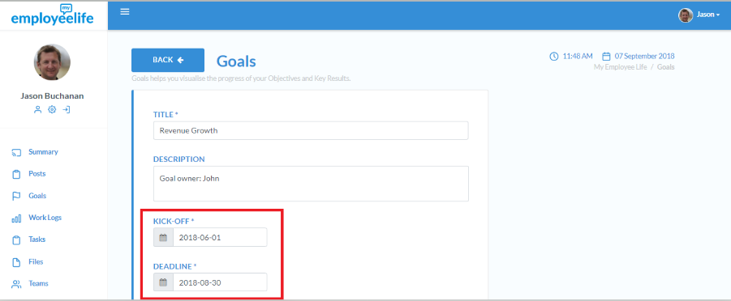
Set the Start Date and End Date.

Under the Goal dashboard, click the “+’ to add a goal.

Type in the “Title” of the Goal and the details on the “Description” tab. You may also include a tag to organise your goals. Set the kick off date and deadline.
If you want to share the goal with your team members, simply click the “Private” button and share goals with at least your supervisor.
If you want to keep this goal to yourself, just keep it as it is.
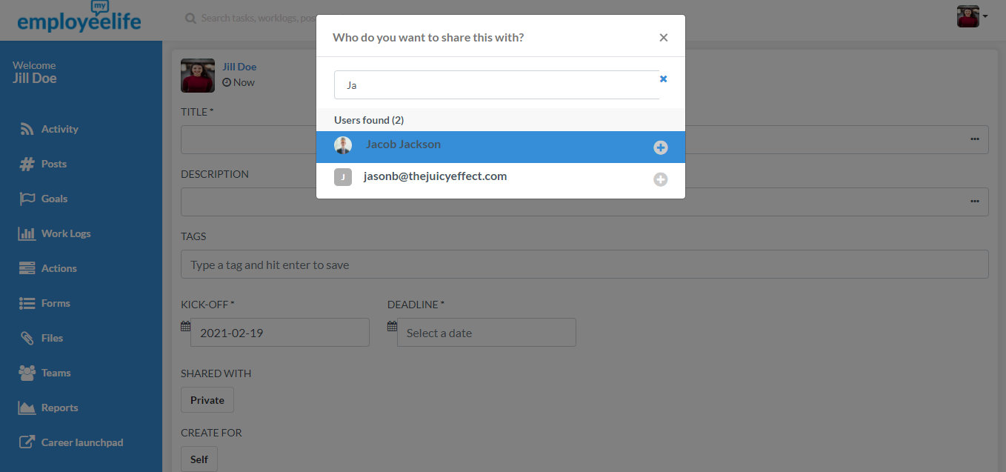

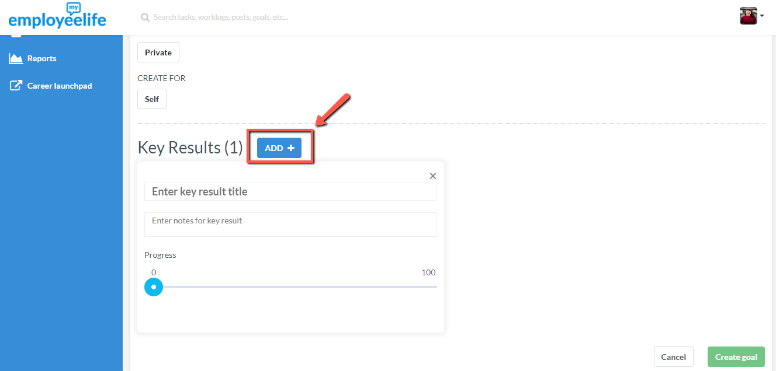
To add “Key Results”, click “Add +” button.

Type the title of the new key result.

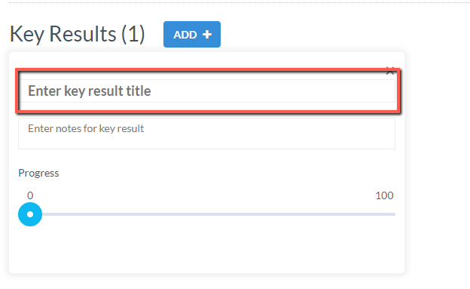

Add notes (if applicable) and adjust the progress bar according.
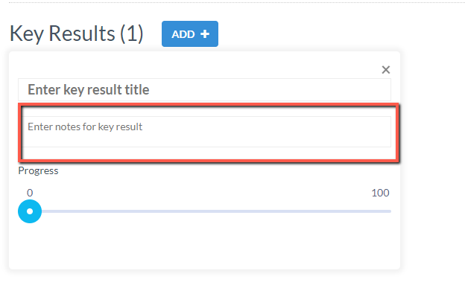

Further key results can be added by repeating the above steps.

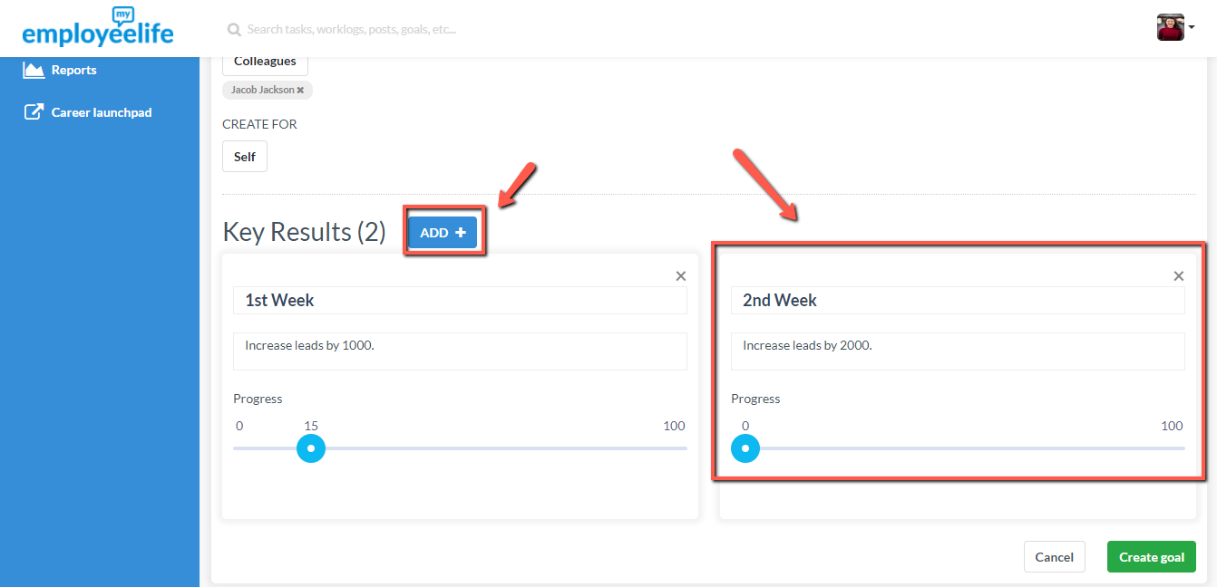

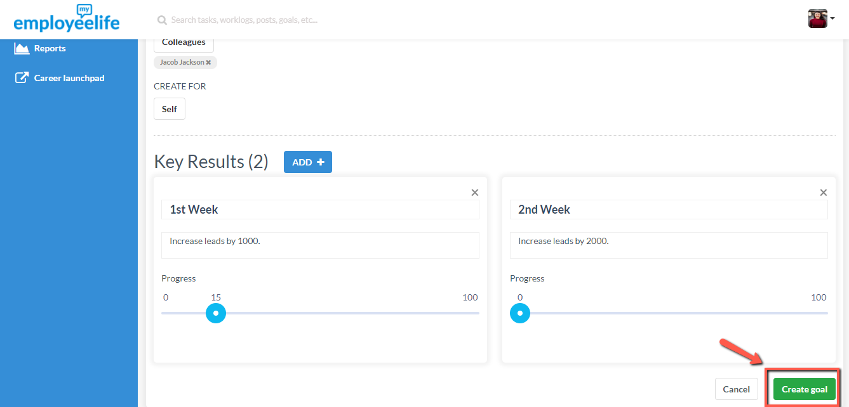
Click Create Goal button to save all Goal.

Work Logs
A Work Log is a place to log information about your own performance that your boss should know about, or you want to retain for performance review time. Examples of how you might use this are:
- Work diary. Keep a weekly record of what has been achieved, as well as problems and opportunities, to share with your manager when performance review time rolls around. This is particularly useful to ensure you don’t forget all the great things you have done.
- Keep your manager up to date with what you have been doing. You also have the option to share this with your team or anyone else . When this is completed and shared, it will appear on their News Feed.
The work log can only be seen by you unless you choose to share it with someone else. Here’s how to create a work log…

Click on the Work Log Menu item
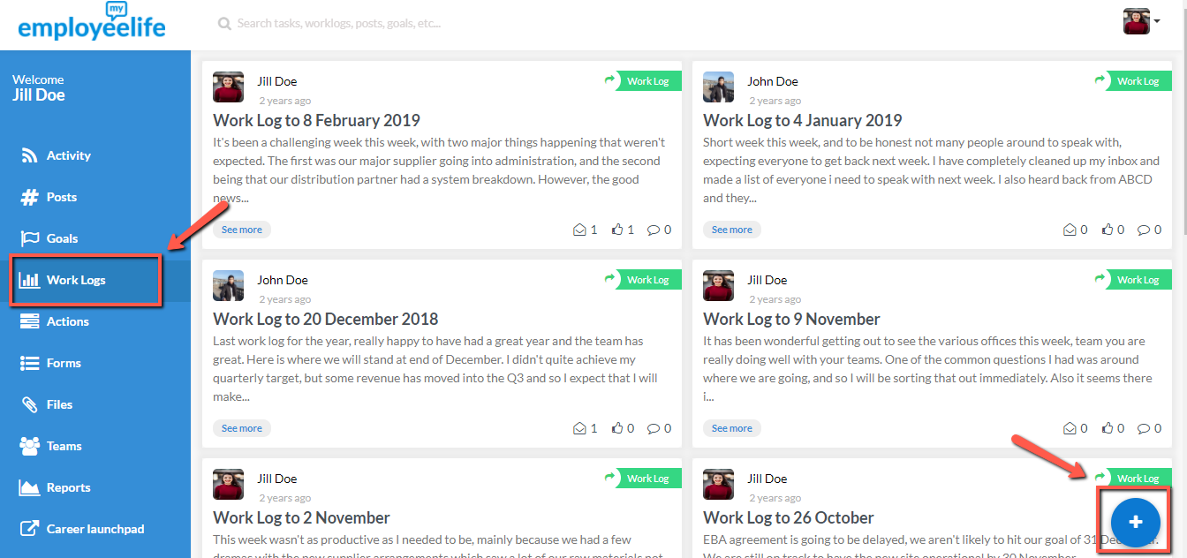

Give your work log a title.

You may also attached files, or posts, worklogs, goals, and tasks.

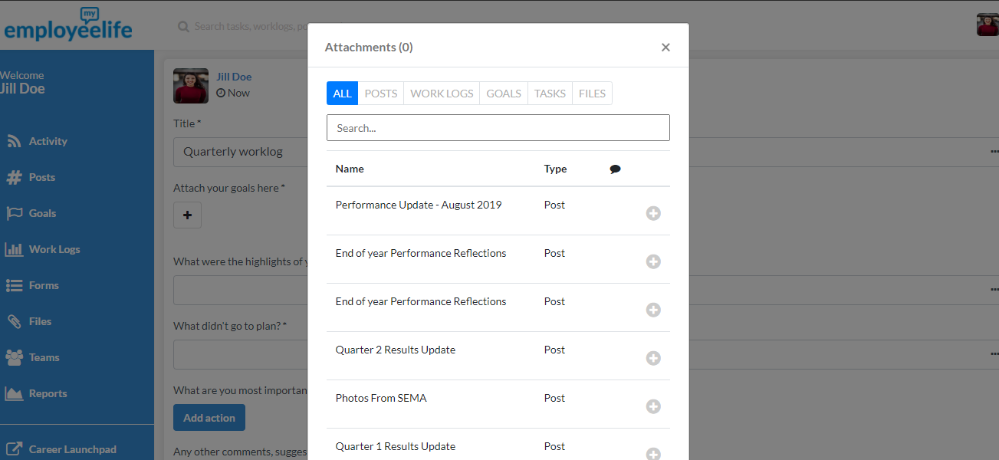

Click the “Private” button to add people to share with.

Type the name of colleague or group to whom the work log is to be shared with, or select from the list.

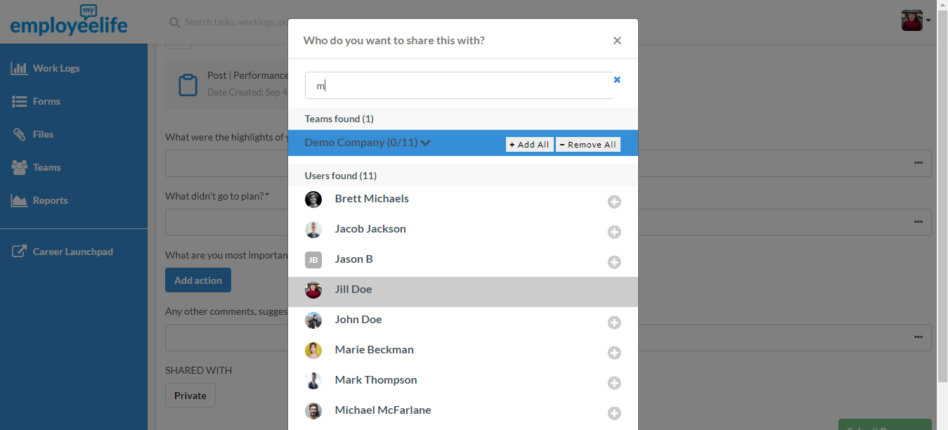

Click Post button to post the work log.

ACTIONS
My Employee Life comes with a simple task management capability called “Actions”. It helps you to remember certain things that you or your team shouldn’t forget to do (yes, you can assign tasks to others).
It is possible to comment and update Actions and keep a record of those things that have been completed over time. Actions is also useful for team members to know what has been completed and can be added to a work log. Either assigner or assignee can update Actions. Actions assigned to you will show up on the Actions Page. Here’s how to create Actions…

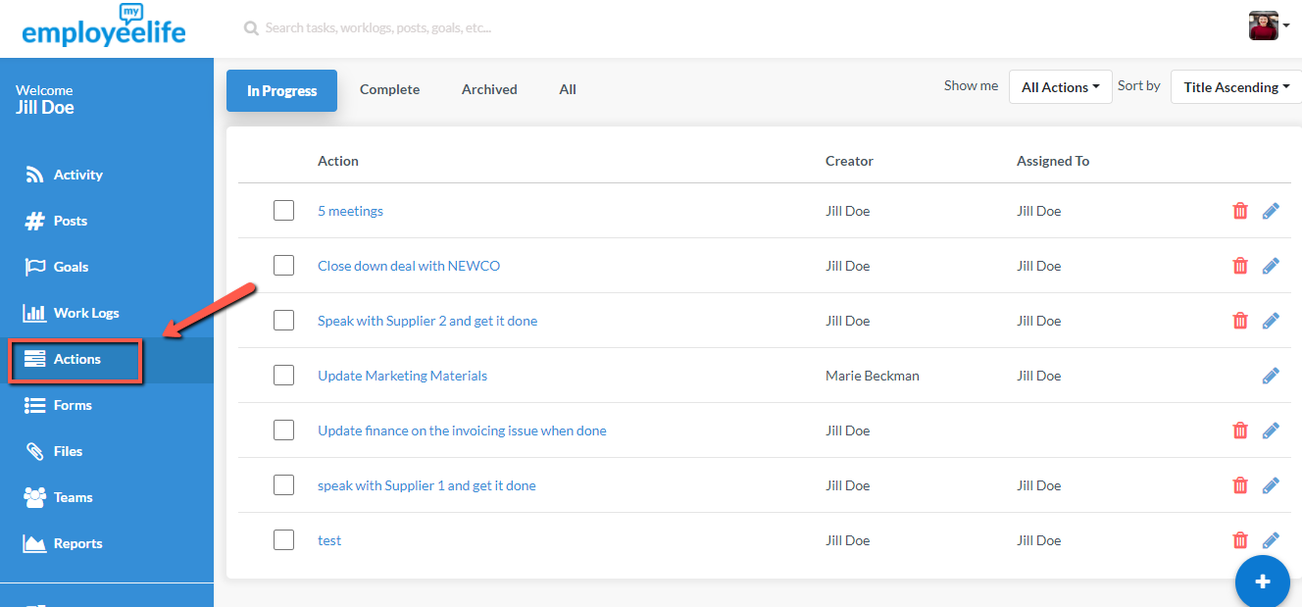
Click Actions menu from the Sidebar.

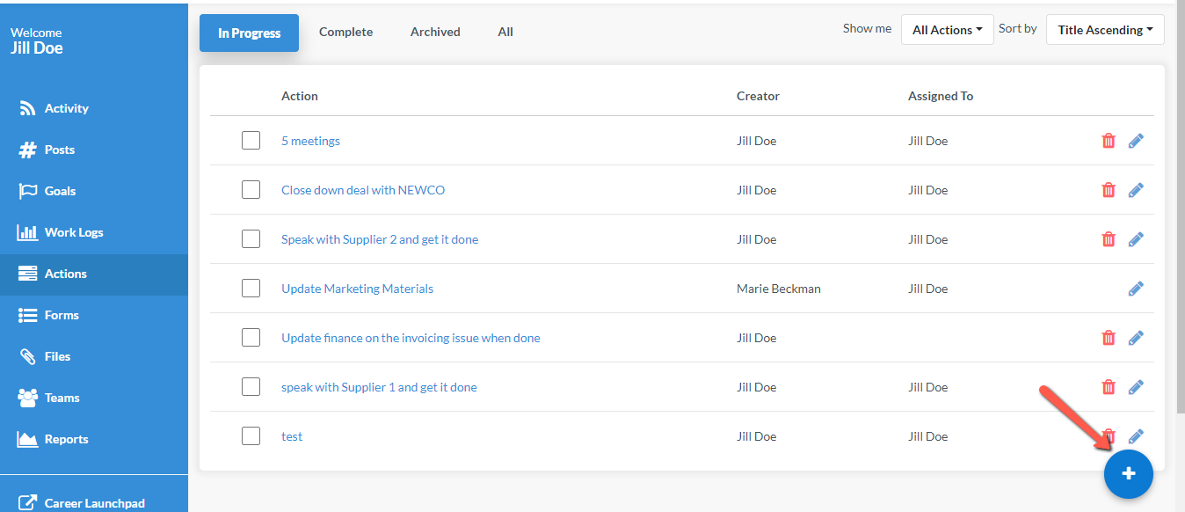
Click the Add+ button to add a task.

Type the Title of the Task on the text field and add notes if applicable.

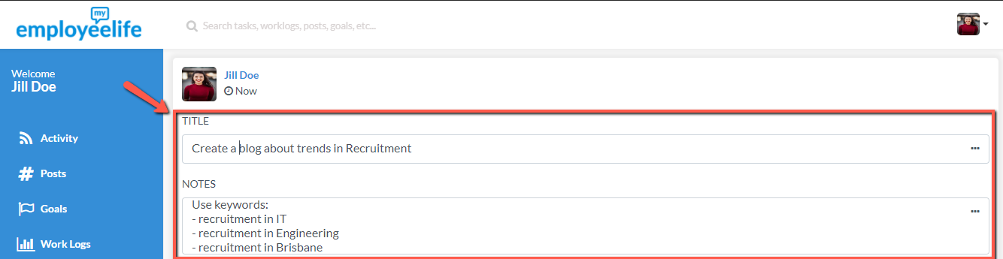

Add the Due Date
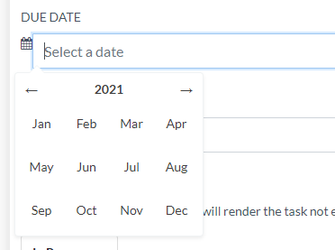

Type the name (first or last name) of the assignee in the text field. Select the assignee from the list.

Set the status of the task.
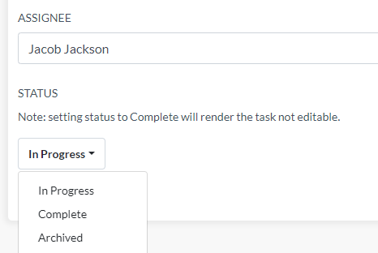

Click Create Action button to save the new Task.

Actions are visible on the Actions Page. You will see Actions based on their status – “In Progress”, “Complete”, “Archived”, and “All”
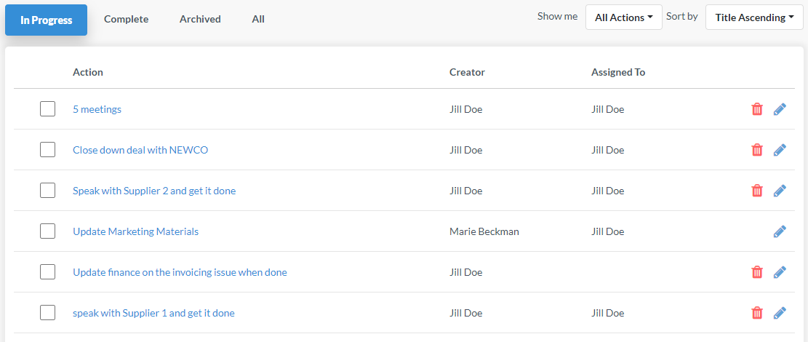

Files
My Employee Life allows you to also store important files that are relevant to your Employee Life. Here’s how to upload/share a file…

Click the Files tab on the side bar of the dashboard. Click the “+ New Folder” to upload a folder and “+ New File” to upload a single file.
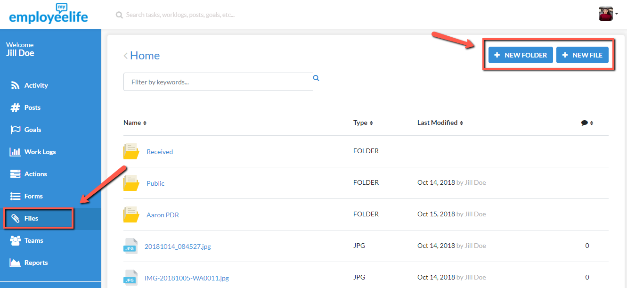

Drag and drop or browse files you want to upload.

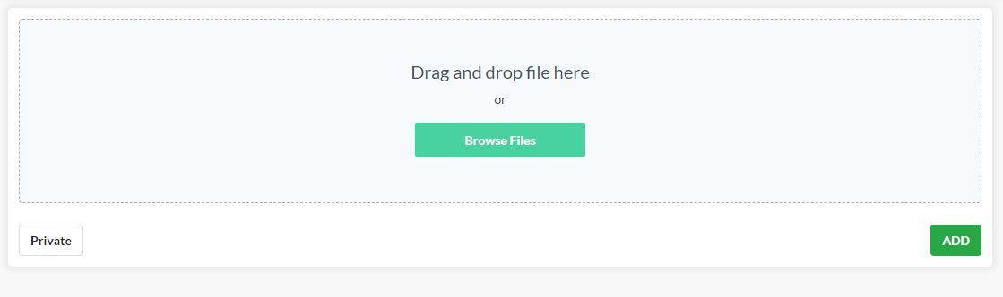

To share a file with your team, click the “Private” button. Type in the name or select the group you want to share the file with.

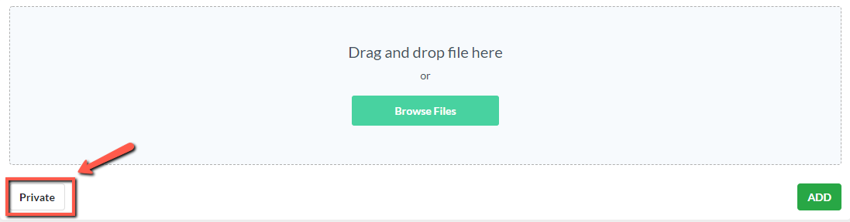

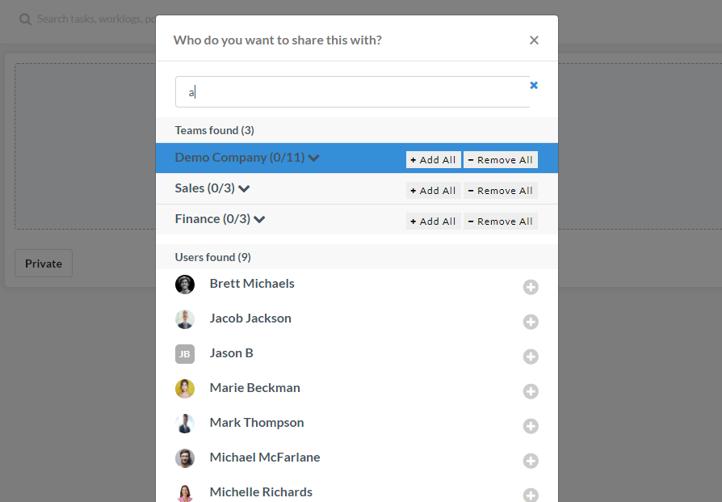

2.5.5 Click Add to add file to your files directory.
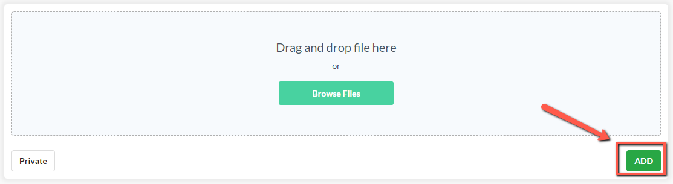

Teams
Teams is where you can find colleagues and team members, view their profile, and view anything they have shared specifically with you. Team groupings are created by the Administrator. You will see the groups you are associated with on the left side of the screen. The Employee Life Administrator is the only one who can alter the details of permanent groups (e.g. Departments).
To find/view information about an individual, group or organisation, simply click on the relevant group, and search for the person you are after. Here’s how to view a colleague’s profile…

Click Teams on the side menu.
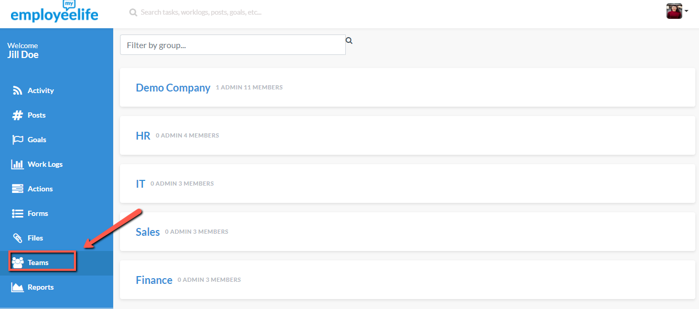

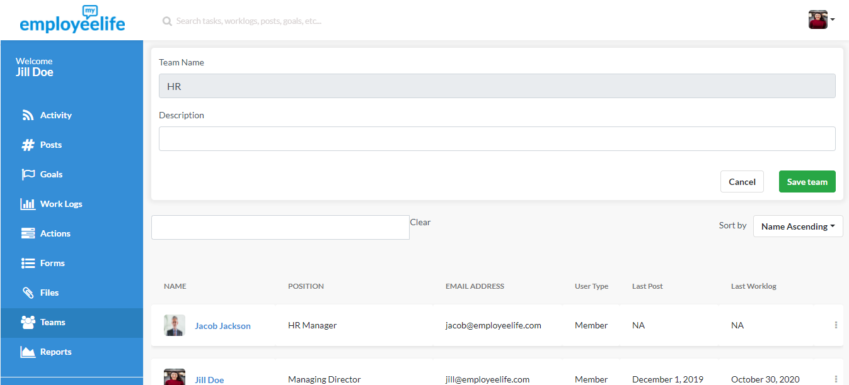
Click the department of the team member you are looking for. And it will direct you to the list of all the team members of that department

Click the profile of the person you are looking for and you may now view the information that has been shared to you from the person.

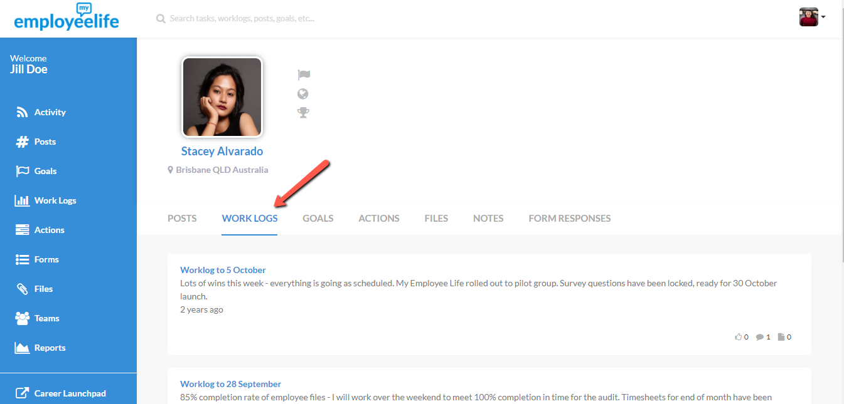

BRINGING IT ALL TOGETHER - CREATING AND MAINTAINING A ‘PERFORMANCE DRUMBEAT’
One of the big questions many Company leaders are asking themselves at the moment is - how is it possible to keep improving workplace performance in a sustainable way?
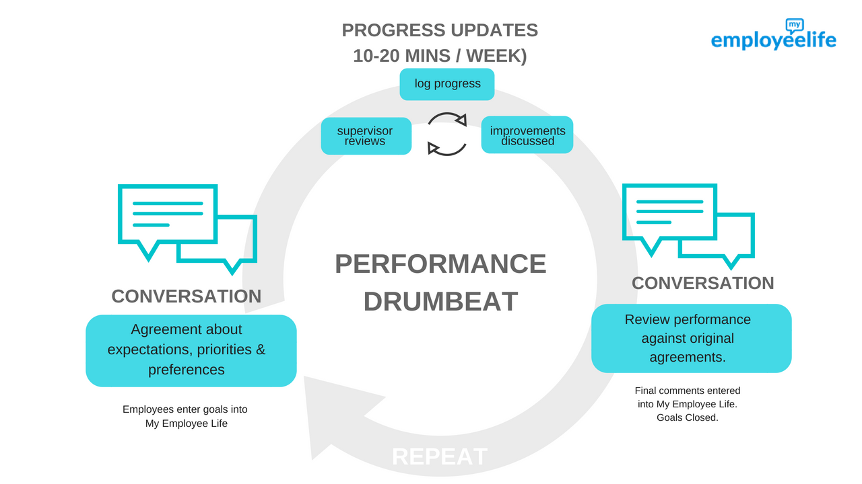
My Employee Life helps to solve this problem by supporting what we call ‘the performance drumbeat’. Quite simply, this is the minimum set of habits everyone in a company should be doing to keep everything moving in the right direction. It looks like this:

Step 1: Company/Team sets its objectives
The Leadership Team will usually set the Company’s Objectives for the year prior to the start of the year. This sets the priorities for the period and helps to provide guidance and focus.
Quarterly Drumbeat:
Team members discuss with their supervisor what is expected in the coming period, and ‘where we should be by the end of the period’. It is also worth discussing any professional development objectives as well as any standards and other agreements that are important. Values is a common talking point. Once agreed, objectives and key results can be entered into My Employee Life and shared with the boss.
Weekly/Regularly:
It is common for a supervisor and team member to agree to meet regularly – for example weekly, to discuss progress. If there is no formal drumbeat for ‘catchups’, they tend to be forgotten. A great way to prepare for these meetings (whether in person or online) is for everyone to spend 10 minutes each week keeping a work log, reflecting on the week that was. These work logs then provide a great discussion point. It is also important to keep goal progress up to date (with the goal progress indicator).
On a day-to-day basis, employees and their supervisors may choose to use the Tasks functionality to stay on top of what needs doing.

Performance Reviews
Your Company will have its own set of processes about how performance is evaluated and reviewed. By creating a regular Work Log and ensuring that you and your Supervisor keep important comments along the way, performance reviews are more likely to be fair and based on actual performance over the period involved.
If paper forms are used, these can be scanned and uploaded to your files area. Here is a way to use My Employee Life instead of paper-based forms.
At the end of the period, team members should finalise their goal progress, and add any comments that are relevant to summarise the performance. Either before or during a meeting, Supervisors should also add their comments. When both agree that everything has been added and agreed, a goal can be ‘closed’ which means it can be viewed, but no longer edited.
My Employee Life therefore keeps an ongoing record of performance.

